1. What Design Pattern is most probably used in the following UML diagram?

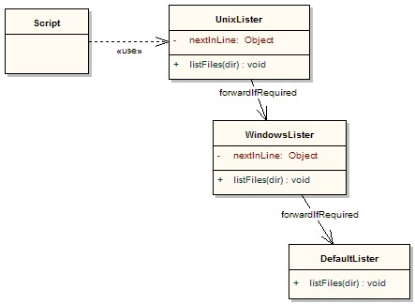

* Command
* **Chain of Responsibility**
* Observer
* Strategy

1. ______ design pattern allows an Object to change its behavior based on its internal state.

* Strategy
* Decorator
* **State**
* Bridge

1. [Composite] Which operation must be shared between Composite, Component and Leaf?

* add
* remove
* getChild
* **none of the above**

1. What design pattern is related with the methods first(), next(), currentItem(), isDone()?

* **Iterator**
* Chain of responsibility
* Composite
* Decorator

1. Should I use the State Design pattern for only two states?

* **Yes**
* No, it's not worth it.
* No, better to use other design pattern
* All above are incorrect

1. What design pattern does the following UML diagram depict?

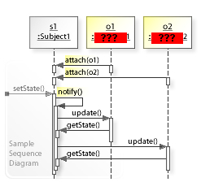

* **Observer**
* Visitor
* State
* Chain of Responsibility